Integrating Artificial Intelligence with KMV Models for Comprehensive Credit Risk Assessment

[**Kangming Xu**](https://dl.acm.org/doi/abs/10.1145/3307339.3343254)**1*, Vishal Jangir2**

1 Computer Science and Engineering , Santa Clara University, CA, USA

2 Department of Information Technology, Manipal University Jaipur, Jaipur, India

rexcarry036@gmail.com

Abstract: *With the continuous development of artificial intelligence and various new intelligent algorithm technologies, the business contacts between various institutions within financial enterprises are gradually increasing, and traditional financial risk management can no longer adapt to the current status quo in the era of big data. The lack of information sharing among institutions can reduce the efficiency of financial management and adversely affect the operation of enterprises. At present, financial credit risk mainly includes credit risk, market risk and operational risk. Credit risk relates to the possibility that a borrower will not be able to repay loans or debts on time, market risk covers potential losses caused by market volatility, price changes and adverse events, while operational risk includes risks such as internal operational errors, technical failures and fraud, which may adversely affect the normal operations and financial condition of a financial institution. These risk factors need to be integrated and managed in the financial sector to ensure financial stability and customer trust. Therefore, this paper aims to establish a KMV financial credit risk model, continuously strengthen the internal risk management of enterprises, achieve management modeling and a good KMV algorithm mechanism, and realize the cooperation and stickiness between customers and enterprises, so as to avoid unnecessary financial risks.*

Keywords: Intelligent algorithm; Financial credit risk; KMV Model building; Cloud computing

# **INTRODUCTION**

With the advent of the era of artificial intelligence, the traditional financial model has been impacted, and the application of traditional financial risk management model in enterprises will reduce the operation efficiency of enterprises. Therefore, enterprises should actively use big data technology to adjust management strategies. Deep learning and new intelligent technologies can provide enterprises with more comprehensive data information, so that they can effectively respond to a variety of risk issues[1-3]. In the era of big data, corporate financial risk management can obtain a comprehensive and in-depth understanding of the production and operation status of enterprises through the collection of production, sales, financial and other information data of enterprises. At the same time, through the analysis of corporate financial data, possible or existing financial risks can be found in time and countermeasures can be formulated[4].

In recent years, the combination of the financial industry and artificial intelligence has brought many significant benefits. First, AI technology can accelerate the financial decision-making process, enabling financial institutions to assess credit risk, market volatility, and investment opportunities more quickly. Second, AI can improve the accuracy of financial models by analyzing large amounts of unstructured and real-time data to more accurately identify potential risks[5-7]. In addition, automation and machine learning can reduce operational risk, reducing the risk of erroneous transactions and fraudulent activities. Most importantly, financial institutions can enhance customer service through AI, providing personalized recommendations and solutions that enhance customer satisfaction. Traditional methods often rely on historical data and statistical models, which are difficult to deal with non-linear and complex market conditions[8]. AI can process large-scale data, including unstructured data, to better capture the dynamics of the market. In addition, traditional models may ignore potential non-traditional risk factors, while the KMV model algorithm combined with artificial intelligence can consider various risk factors more comprehensively. Overall, the combination of finance and AI provides institutions with stronger, more precise, and faster risk management tools that promise to reduce potential

1. **RELATED WORK**

Almost all the business of finance is dealing with risk, and the lenders who bring you money must want you to be a good person who keeps his word[9]. Therefore, when you apply for personal credit cards or small loans, you need to fill in some personal information, such as age, job, income, education, etc. Banks and lending institutions will review this information, and then decide whether to release the loan. However, if it is only a small amount, such as less than 10,000 yuan, then the cost of one audit is definitely rising, so there is a need for a set of automated decision-making tools to determine who are good people and who are bad people, then the credit score card model will come in handy, so in the process of dealing with financial enterprises, credit score is an indispensable part[5]. A credit score is a quantitative measure of how creditworthy you are. Does that sound like a mouthful? To put it simply, it is a score, calculated from your personal information and some third-party data, such as Alipay's Sesame Credit[10-12], Tencent's Tencent Credit, and the FICO score in the United States. These scores determine your credit rating, allowing lenders to decide whether or not to lend.

In order to better realize the management of financial enterprises and the prevention of financial risks, it is necessary to use some artificial intelligence algorithm models in the process of establishing credit models, the industry often says that there are A card, B card, C card, A card is to apply for score cards. When you apply, you will stand up and decide not to lend money, B card, that is, the behavior score card in the loan, monitors your credit status, decides not to give you a line, or does not interrupt your loan, C card is the score card after the loan, there are generally three kinds of: aging transfer model, repayment rate model and lost contact warning model.

1. Lost contact early warning model: for banks and loan companies, sometimes they are not afraid that you do not pay back the money, if you are overdue, you can also make a profit by means of penalty interest, etc., but they are more afraid of losing contact with customers and completely disappearing, so they need to establish a lost contact early warning to see if you may lose contact in the future[13-15].

2.KMV model：From the perspective of credit risk management methods, the current foreign research on credit risk and related credit risks

The theory is relatively complete and has been widely used in the financial industry. Some pioneering research results have greatly promoted the development of the field of credit risk, and have certain reference significance for promoting the development of this field in our country. [16]The study of credit risk and the measurement of default probability by KMV model can help investors and enterprises to deal with adverse selection and moral hazard caused by asymmetric credit rationing information in the financial market. It will help the financial industry reduce costs, enhance stability and industrial optimization and upgrading, and achieve effective allocation of credit resources.

**2.1** **Loss paradigm risk model**

There are two basic ways to measure credit portfolio losses. The first is the defaul mode. This model recognizes losses only when the debtor has already defaulted on its obligations during the term of the debt. This model is useful in situations where market value is not available or the term is short. [17]The second is the mark-to-market paradigm, which recognizes any gain or loss caused by a change in the debtor's credit quality during the period being measured.

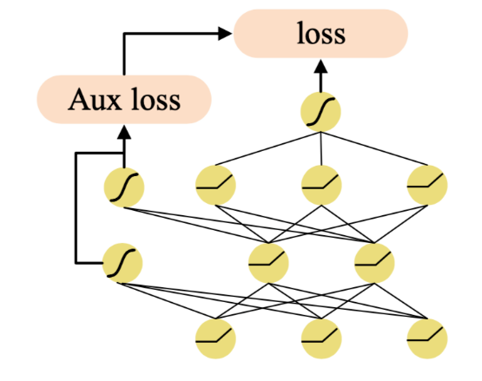

**Figure 1:** The structure of DNN with auxiliary losses

The market value of the debt is obtained by discounting cash flows based on the debtor's credit curve. In the mark-to-market model, there are two methods of estimating cash flow, which also correspond to methods of measuring credit quality. The first is to use discrete measures of credit quality, such as the credit ratings of Standard & Poor's or Moody's[18-21]. The second is to use the debtor's default probability as a continuous measure of credit quality. Using a valuation model when looking at the calculation of the ending debt value, among them, default probability, time to maturity and estimated recovery value givendefault under the condition of default are the inputs of the model.

**2.2 KMV and Bayesian model**

There are three methods to estimate the default ratio: Merton model, actuarial model and measurement method.

(1) Merton model:

The calculation of default probability is based on the company's capital structure and the rate of asset change. This model treats the equity of the company as a call option based on the assets of the company. [22]KMV's method for estimating default rates relies on an options valuation framework and equity market information.

The asset value is the product of the face value of the bond and the default recovery rate; In the non-default scenario, the predicted value of the credit asset when it is converted to a credit rating n after some time in the future:

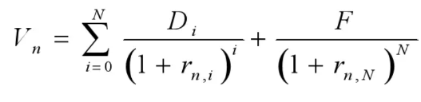(1)

In formula (1), Vn is the value of the credit asset with a credit rating of n after one year, N is the remaining term of the credit asset, Di is the interest generated by the credit asset in year i, F is the par amount of the credit asset, rn and i are the return on investment required by the credit asset with a credit rating of n in year.

KMV model and credit metrics model are the two most popular credit risk management models in the international financial community. [23]Both of them can be used by banks and other financial institutions to measure the credit status of the credit recipients, analyze the credit risks they face, prevent centralized credit granting, and then provide a quantitative and more scientific basis for investment diversification and specific credit granting decisions, and provide a good compensation for the traditional credit analysis methods characterized by subjectivity and artistry.

(2) Actuarial model

The modeling process of credit model is a kind of rate calculation process for insurance companies to determine the future premium according to the past risk occurrence, which plays an important role in the determination of experience rate[24-26]. According to the application of empirical data in the rate determination process, the credit model is divided into limited fluctuation credit model and maximum precision credit model This approach, like that of credit-rating firms, assigns a rating to each credit based on qualitative and quantitative data in a simulation of the Estimated Default Frequency. These levels form a matrix that determines the probability that the debtor's rating will change over a certain period of time. Commonly known as transition probability matrix. Credit Risk+ takes this approach.

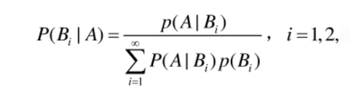(2)

Bayesian model and KMV (Korpus Miller-Varshavsky) model can be combined to form a more comprehensive approach to financial credit risk management. Generally, using Bayesian statistical methods, credit scoring models can be continuously updated and improved to more accurately estimate the credit risk of individuals or companies. Bayesian models can combine historical data with the latest information to dynamically adjust credit scores to better reflect changes in risk. [27]Secondly, the establishment of risk modeling KMV model is usually used to estimate the probability of default and risk loss. Combined with a Bayesian approach, additional data sources such as market data, macroeconomic indicators, and industry trends can be brought in to more fully assess potential credit risks. [28]In everyday credit risk, Bayesian methods can be used to improve anti-fraud systems and detect unusual behavior and fraud patterns.

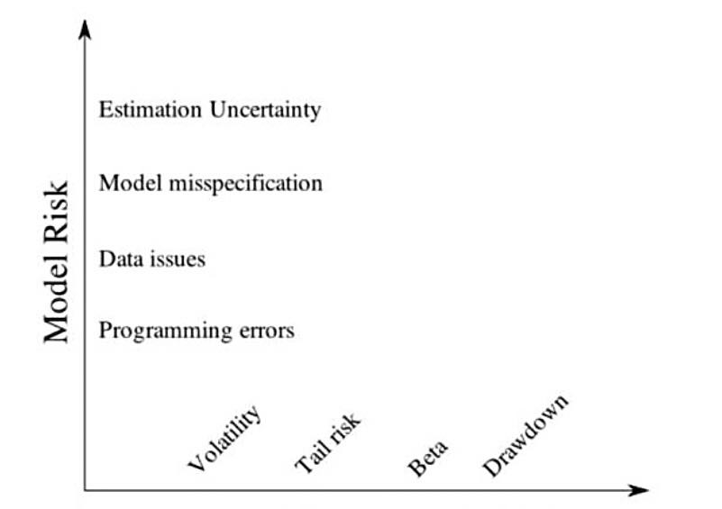

**Figure 2:** Bayes Systematic and Unsystematic Risk

The KMV model can be integrated with these systems to provide more comprehensive risk alerts. [29]In general, combining Bayesian model and KMV model can improve the accuracy and real-time of financial credit risk management. This combination allows financial institutions to better understand and respond to evolving credit risks and better meet regulatory requirements. In practical applications, however, it is necessary to determine how best to combine the two approaches depending on the specific situation and data availability.

# **Methodology**

KMV model is mainly developed based on BSM model and Merton's pricing model, with strong foresight, which can realize the purpose of monitoring the company's credit risk. KMV model is highly dynamic, integrating the company's long-term and short-term liabilities, stock price, stock price volatility and other data, and then modeling to calculate the default distance[30-33]. It can better quantify the level of risk, which is one of the most commonly used methods to measure credit risk at present.

**3.1 Risk models assume predictions**

The KMV model needs to satisfy the following assumptions

The KMV model needs to meet the basic assumptions in the BS formula. The stock price of the enterprise satisfies the wandering of random process and occurs frictionless in the transaction. Meanwhile, the equity value and asset value of the enterprise meet the geometric Brownian motion within the range of change.

Securities can be short sold in the financial market, and there is no possibility of risk-free arbitrage; The underlying securities may be divided indefinitely and continuously without paying interest on the shares;

The risk-free rate does not change with the maturity before maturity;

The application principle of KMV[34] model can be regarded as a call option, the subject matter of the call option is the asset value of the company, and the strike price is the book debt value of the company. When the value of the subject matter of the call option is greater than the strike price, the company has a good repayment ability, not only will there be no default, but also the shareholders of the company can get benefits; When the value of the subject matter of the call option is less than the strike price, the company will face insolvency, which will lead to default. In the actual operation process of KMV model, the core is to use [35]MATLAB software programming to realize the calculation of the company's asset volatility and asset value.

According to the above analysis, the Black-Scholes-Merton option pricing formula can be obtained:

(3)

Where VE represents the market value of equity, D represents the book value of liabilities, a represents the market value of enterprise assets, t represents the time range, r represents the risk-free interest rate, and N represents the cumulative normal distribution function. In the equation:

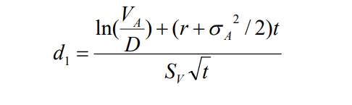(4)

(5)

According to the fact that equity value VE is a function of asset value VA and time t, and the movement trajectory of asset value VA is similar to Brownian motion, it can be seen that the movement trajectory of equity value e is also the trajectory of Brownian motion, that is to say, the credit risk model can be predicted by realizing asset value and time function[13].

**3.2 Data setting and calculation**

①D Equity value VE, before China's share reform, the equity value can be obtained by converting the stock price of tradable shares and the value of restricted shares. However, on May 9, 2005, China launched the reform of non-tradable shares. After the completion of the annual share reform of non-tradable shares, the calculation of equity value is relatively simple, only the value of tradable shares can be calculated. Therefore, when calculating the equity value of listed companies in the financial industry, the formula VE= number of outstanding shares * annual closing price of outstanding shares is selected[36-37].

② Closing price Volatility of equity value δE, the daily volatility of the stock is calculated based on the logarithmic return rate, and then the annualized standard deviation is calculated as the volatility of equity value.

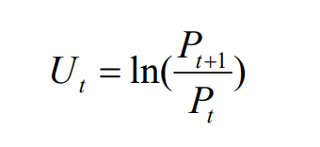(6)

The daily volatility of stock returns of companies in the financial industry is:

(7)

Where: n is the number of trading days in the whole year, and the annual volatility of stock returns is:

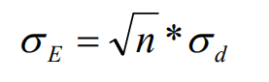(8)

When calculating the number of trading days in the whole year, we do not use the common n-250, but calculate the volatility of equity value according to the value of the actual trading days of the stock in these five years, and the data is more accurate.

(3) Time period t and debt term are important parameters in the credit risk assessment model. The data in this paper are selected and brought into the model, and the unit is '1 'when the sample is processed.

(4) Risk-free interest rate r, as the official website of the People's Bank of China found that the one-year time deposit interest rate has remained at 1.5% since October 2015, and has not changed so far. Therefore, this paper selects the Shanghai Interbank offered Rate (SHIBOR) for measurement in one year, and the KMV model generally annualizes this interest rate because continuous compound interest is generally measured, so it is transformed into continuous compound interest rate as a risk-free interest rate.

# **Conclusion**

Generally speaking, from the analysis of the capital market system, the KMV model mainly evaluates the credit risk of the financial market based on the mature default risk database. Only when the above conditions are guaranteed, can the model give better play to its advantages. At present, listed companies are not transparent enough in the disclosure of financial information, and there are some phenomena such as financial whitewashing and untimely information disclosure. Meanwhile, the scale and efficiency of margin financing and short selling in China's capital market are relatively low, and the market effectiveness is not high [38-39]. Therefore, the CSRC needs to make careful planning plans. In view of the existing phenomena such as the improvement of market effectiveness and the imperfect enterprise information disclosure system, the corresponding system is proposed to improve, and the development of the capital market is established to provide favorable realistic conditions for the measurement of modern credit risk measurement models.

Finally, combining AI with the KMV (Korpus-Miller-Varshavsky) model to look into the future of financial credit risk management allows for more accurate, real-time and comprehensive risk assessment. Ai's big data analytics and machine learning capabilities will enable financial institutions to better predict default risk, while the flexibility of Bayesian statistical methods can help continuously optimize models to better reflect market changes [40]. This combination is expected to improve the efficiency of credit decisions, reduce credit losses, and provide a more accurate measure of risk, helping the financial industry respond more soundly to future credit challenges.

**REFERENCES**

1. Liu, Y., Tan, H., Cao, G., & Xu, Y. (2024). Enhancing User Engagement through Adaptive UI/UX Design: A Study on Personalized Mobile App Interfaces.
2. Huang, D., Yang, M., Wen, X., Xia, S., & Yuan, B. (2024). AI-Driven Drug Discovery: Accelerating the Development of Novel Therapeutics in Biopharmaceuticals. Journal of Knowledge Learning and Science Technology ISSN: 2959-6386 (online), 3(3), 206-224.
3. Yang, M., Huang, D., Zhang, H., & Zheng, W. (2024). AI-Enabled Precision Medicine: Optimizing Treatment Strategies Through Genomic Data Analysis. Journal of Computer Technology and Applied Mathematics, 1(3), 73-84.
4. Wen, X., Shen, Q., Zheng, W., & Zhang, H. (2024). AI-Driven Solar Energy Generation and Smart Grid Integration A Holistic Approach to Enhancing Renewable Energy Efficiency. International Journal of Innovative Research in Engineering and Management, 11(4), 55-55.
5. Lou, Q. (2024). New Development of Administrative Prosecutorial Supervision with Chinese Characteristics in the New Era. Journal of Economic Theory and Business Management, 1(4), 79-88.
6. Liu, Y., Tan, H., Cao, G., & Xu, Y. (2024). Enhancing User Engagement through Adaptive UI/UX Design: A Study on Personalized Mobile App Interfaces.
7. Xu, H., Li, S., Niu, K., & Ping, G. (2024). Utilizing Deep Learning to Detect Fraud in Financial Transactions and Tax Reporting. Journal of Economic Theory and Business Management, 1(4), 61-71.
8. Li, S., Xu, H., Lu, T., Cao, G., & Zhang, X. (2024). Emerging Technologies in Finance: Revolutionizing Investment Strategies and Tax Management in the Digital Era. Management Journal for Advanced Research, 4(4), 35-49.
9. Shi J, Shang F, Zhou S, et al. Applications of Quantum Machine Learning in Large-Scale E-commerce Recommendation Systems: Enhancing Efficiency and Accuracy[J]. Journal of Industrial Engineering and Applied Science, 2024, 2(4): 90-103.
10. Wang, S., Zheng, H., Wen, X., & Fu, S. (2024). DISTRIBUTED HIGH-PERFORMANCE COMPUTING METHODS FOR ACCELERATING DEEP LEARNING TRAINING. Journal of Knowledge Learning and Science Technology ISSN: 2959-6386 (online), 3(3), 108-126.
11. Lei, H., Wang, B., Shui, Z., Yang, P., & Liang, P. (2024). Automated Lane Change Behavior Prediction and Environmental Perception Based on SLAM Technology. arXiv preprint arXiv:2404.04492.
12. Wang, B., Zheng, H., Qian, K., Zhan, X., & Wang, J. (2024). Edge computing and AI-driven intelligent traffic monitoring and optimization. Applied and Computational Engineering, 77, 225-230.
13. Xu, Y., Liu, Y., Xu, H., & Tan, H. (2024). AI-Driven UX/UI Design: Empirical Research and Applications in FinTech. International Journal of Innovative Research in Computer Science & Technology, 12(4), 99-109.
14. Li, H., Wang, S. X., Shang, F., Niu, K., & Song, R. (2024). Applications of Large Language Models in Cloud Computing: An Empirical Study Using Real-world Data. International Journal of Innovative Research in Computer Science & Technology, 12(4), 59-69.
15. Ping, G., Wang, S. X., Zhao, F., Wang, Z., & Zhang, X. (2024). Blockchain Based Reverse Logistics Data Tracking: An Innovative Approach to Enhance E-Waste Recycling Efficiency.
16. Xu, H., Niu, K., Lu, T., & Li, S. (2024). Leveraging artificial intelligence for enhanced risk management in financial services: Current applications and future prospects. Engineering Science & Technology Journal, 5(8), 2402-2426.
17. Shi, Y., Shang, F., Xu, Z., & Zhou, S. (2024). Emotion-Driven Deep Learning Recommendation Systems: Mining Preferences from User Reviews and Predicting Scores. Journal of Artificial Intelligence and Development, 3(1), 40-46.
18. Wang, Shikai, Kangming Xu, and Zhipeng Ling. "Deep Learning-Based Chip Power Prediction and Optimization: An Intelligent EDA Approach." International Journal of Innovative Research in Computer Science & Technology 12.4 (2024): 77-87.
19. Ping, G., Zhu, M., Ling, Z., & Niu, K. (2024). Research on Optimizing Logistics Transportation Routes Using AI Large Models. Applied Science and Engineering Journal for Advanced Research, 3(4), 14-27.
20. Shang, F., Shi, J., Shi, Y., & Zhou, S. (2024). Enhancing E-Commerce Recommendation Systems with Deep Learning-based Sentiment Analysis of User Reviews. International Journal of Engineering and Management Research, 14(4), 19-34.
21. Xu, K., Zhou, H., Zheng, H., Zhu, M., & Xin, Q. (2024). Intelligent Classification and Personalized Recommendation of E-commerce Products Based on Machine Learning. arXiv preprint arXiv:2403.19345.
22. Xu, K., Zheng, H., Zhan, X., Zhou, S., & Niu, K. (2024). Evaluation and Optimization of Intelligent Recommendation System Performance with Cloud Resource Automation Compatibility.
23. Zheng, H., Xu, K., Zhou, H., Wang, Y., & Su, G. (2024). Medication Recommendation System Based on Natural Language Processing for Patient Emotion Analysis. Academic Journal of Science and Technology, 10(1), 62-68.
24. Zheng, H.; Wu, J.; Song, R.; Guo, L.; Xu, Z. Predicting Financial Enterprise Stocks and Economic Data Trends Using Machine Learning Time Series Analysis. Applied and Computational Engineering 2024, 87, 26–32,
25. Zhang, Xuyang, et al. "Research on Credit Risk Assessment Optimization based on Machine Learning." (2024).
26. Huang, D., Xu, L., Tao, W., & Li, Y. (2024, August). Research on genome data recognition and analysis based on Louvain algorithm. In Fourth International Conference on Biomedicine and Bioinformatics Engineering (ICBBE 2024) (Vol. 13252, pp. 233-238). SPIE.
27. Xu, J., Yang, T., Zhuang, S., Li, H. and Lu, W., 2024. AI-based financial transaction monitoring and fraud prevention with behaviour prediction. Applied and Computational Engineering, 77, pp.218-224.
28. Ling, Z., Xin, Q., Lin, Y., Su, G. and Shui, Z., 2024. Optimization of autonomous driving image detection based on RFAConv and triplet attention. Applied and Computational Engineering, 77, pp.210-217.
29. He, Z., Shen, X., Zhou, Y., & Wang, Y. (2024, January). Application of K-means clustering based on artificial intelligence in gene statistics of biological information engineering. In Proceedings of the 2024 4th International Conference on Bioinformatics and Intelligent Computing (pp. 468-473).
30. Gong, Y., Zhu, M., Huo, S., Xiang, Y., & Yu, H. (2024, March). Utilizing Deep Learning for Enhancing Network Resilience in Finance. In 2024 7th International Conference on Advanced Algorithms and Control Engineering (ICAACE) (pp. 987-991). IEEE.
31. Xin, Q., Xu, Z., Guo, L., Zhao, F., & Wu, B. (2024). IoT traffic classification and anomaly detection method based on deep autoencoders. Applied and Computational Engineering, 69, 64-70.
32. Yang, T., Li, A., Xu, J., Su, G. and Wang, J., 2024. Deep learning model-driven financial risk prediction and analysis. Applied and Computational Engineering, 77, pp.196-202.
33. Zhou, Y., Zhan, T., Wu, Y., Song, B., & Shi, C. (2024). RNA Secondary Structure Prediction Using Transformer-Based Deep Learning Models. arXiv preprint arXiv:2405.06655.
34. Liu, B., Cai, G., Ling, Z., Qian, J., & Zhang, Q. (2024). Precise Positioning and Prediction System for Autonomous Driving Based on Generative Artificial Intelligence. Applied and Computational Engineering, 64, 42-49.
35. Li, J., Wang, Y., Xu, C., Liu, S., Dai, J., & Lan, K. (2024). Bioplastic derived from corn stover: Life cycle assessment and artificial intelligence-based analysis of uncertainty and variability. Science of The Total Environment, 174349.
36. Xiao, J., Wang, J., Bao, W., Deng, T., & Bi, S. (2024). Application progress of natural language processing technology in financial research. Financial Engineering and Risk Management, 7(3), 155-161.
37. Cui, Z., Lin, L., Zong, Y., Chen, Y., & Wang, S. (2024). Precision Gene Editing Using Deep Learning: A Case Study of the CRISPR-Cas9 Editor. Applied and Computational Engineering, 64, 134-141.
38. Zhang, X., 2024. Machine learning insights into digital payment behaviors and fraud prediction. Applied and Computational Engineering, 67, pp.61-67.
39. Zhou, S., Yuan, B., Xu, K., Zhang, M., & Zheng, W. (2024). THE IMPACT OF PRICING SCHEMES ON CLOUD COMPUTING AND DISTRIBUTED SYSTEMS. Journal of Knowledge Learning and Science Technology ISSN: 2959-6386 (online), 3(3), 193-205.
40. Shang, F., Zhao, F., Zhang, M., Sun, J., & Shi, J. (2024). Personalized Recommendation Systems Powered By Large Language Models: Integrating Semantic Understanding and User Preferences. International Journal of Innovative Research in Engineering and Management, 11(4), 39-49.