A Personalized Causal Inference Framework for Media Effectiveness Using Hierarchical Bayesian Market Mix Models

**Xin Ni1* , Yitian Zhang1.2 , Yanli Pu2 , Ming Wei3 , Qi Lou4**

1.* Business Analytics and Project Management, University of Connecticut, CT, USA

1.2 Accounting, UW-Madison, WI, USA

2 Finance, University of Illinois at Urbana Champaign, IL, USA

3 Finance, Washington University in St. Louis , MO, USA

4 Tian Yuan Law Firm, Hang Zhou, China

*\*Corresponding author E-mail: [rexcarry036@gmail.com](mailto:rexcarry036@gmail.com)*

**Abstract*.***

***This study presents a novel framework for personalized causal inference in media effectiveness using Hierarchical Bayesian Market Mix Models (ABM). The proposed approach integrates individual-level data with aggregate market information to estimate personalized media effects while addressing the challenges of data sparsity and high dimensionality. By combining the identity layer and the optimization process in a Bayesian hierarchical model, the model captures heterogeneity across consumers and provides robust predictions of individual causality. Affect different media.***

***The framework is used for e-commerce business data, which includes 500,000 customers across 50 markets in 24 months. The model shows better prediction performance than the integrated business model, with a 30.4% reduction in RMSE. Empirical results reveal significant heterogeneity in media effectiveness across channels and consumer segments. Email marketing emerges as the most effective channel on average, followed by TV advertising, digital display ads, and social media engagements.***

***Sensitivity analyses and robustness checks, including alternative prior specifications and placebo tests, support the validity of the estimated causal effects. The findings provide valuable insights for media planning and marketing strategy, highlighting the importance of tailored budget allocation and campaign design approaches. This research contributes to the growing body of literature on personalized marketing analytics and offers a powerful tool for estimating individualized media effects in complex marketing environments.***

**Keywords:** Hierarchical Bayesian Models, Market Mix Modeling, Personalized Causal Inference, Media Effectiveness

**1. Introduction**

**1.1. Background on Media Effectiveness and Market Mix Modeling**

In the rapidly changing digital economy, understanding social media has become essential for businesses to improve their marketing strategies and resource allocation. Marketing mix modeling (MMM) has emerged as a powerful tool for evaluating the impact of various marketing factors on business outcomes[1]. Traditional MMM practices have relied on data collection and iterative processes to predict business outcomes. These models provide good insight into the overall performance of the advertising industry, but they often fail to capture the negative impact of individual advertisers on people Use special products.

The emergence of big data and advanced analytics has paved the way for MMM methods to be more efficient. Bayesian methods, in particular, are gaining traction in business economics because of their ability to incorporate prior knowledge and deal with uncertainty in the measurement system. The use of Bayesian methods for marketing mix modeling has enabled marketers to obtain more predictable and effective advertising results, as shown in studies not recently (Zheng et al., 2021; Yang et al., 2020)[2][3].

**1.2. Challenges in Personalized Causal Inference for Media Effectiveness**

While traditional MMM methods provide insight into the overall market, they often fall short of capturing the impact of media coverage across different consumer segments. The growing demand for personalized marketing strategies has emphasized the need for more personalized methods for social media analysis[4]. Individual causal inference in the context of advertising effectiveness presents several challenges:

The sparsity of individual information often affects the estimation of individual advertising effects. The high level of customer satisfaction and media coverage further influence the review[5]. In addition, the possibility of bias and selection bias in the survey data poses a severe problem for business thinking. These challenges are necessary to develop advanced methods to solve the complexities of identifying self-reports.

**1.3. Overview of Hierarchical Bayesian Approaches**

Hierarchical Bayesian modeling has emerged as a robust framework for solving the problem of individual theory in economics. This model uses a hierarchical model of user experience to lend power across multiple levels of aggregation, enabling more robust predictions of individual effects[6]. The Bayesian approach integrates prior knowledge and uncertainty in forecasting, which is essential in business contexts where information may be limited or loud.

Recent studies have shown the effectiveness of hierarchical Bayesian algorithms in many business applications, including customer segmentation, cost optimization, and mixed models [7][8](Li et al., 2019; Huynh et al., 2021). This model has shown superior performance in capturing heterogeneity across customers and provides greater predictability of business outcomes.

**1.4. Research Objectives and Contributions**

This study is designed to develop a personal theory of performance for social media using a hierarchical Bayesian marketing mix model. The proposed method addresses the limitations of the traditional MMM rules by integrating the individual data and the optimization process in the Bayesian hierarchical model. This research aims to develop a hierarchical Bayesian economic mixture model that captures both aggregate and individual-level media effects. To integrate causal inference techniques in the Bayesian framework to estimate the individual causal effects of news channels. The proposed method uses real-world market data and compares its performance with traditional MMM methods[9].

The results of this research are many. First, it extends the existing literature on marketing mix modeling by introducing a new approach that combines hierarchical Bayesian methods with theoretical concepts. Second, it provides business people with powerful tools for predicting individual effects, making businesses more efficient and profitable. Finally, the empirical application of the proposed framework provides insight into the multifaceted effects of news media across different consumer groups, leading to a growing body of knowledge About self-employment[10].

**2. Literature Review**

**2.1. Traditional Market Mix Models**

Market Mix Models (MMMs) are widely used in business analysis to measure the impact of various market factors on business outcomes. These models often use time series regression techniques to predict the results of different trading strategies and strategies. Little's foundational work [11](1979) introduced the concept of business mix modeling, which has evolved to integrate more sophisticated methods.

Traditional MMMs rely on aggregate data, assuming a solid relationship between trading input and output. While these models provide a good understanding of the market, they have limitations in capturing non-linear effects and individual-level heterogeneity. Hansen et al[12]. (2005) reviewed the advances in market mix modeling, highlighting the importance of addressing endogeneity and dynamic effects in market response models.

Recent studies have sought to improve traditional MMMs by incorporating more advanced statistical techniques. Zheng et al. [13](2021) proposed a Bayesian approach to market mix modeling that accounts for both the market's short- and long-term effects. Their model shows better forecasting performance than the MMMs model, especially in capturing the effects of transportation and seasonality.

**2.2. Bayesian Methods in Marketing Analytics**

Bayesian methods have gained significant value in business analysis because of their ability to incorporate prior knowledge, resolve uncertainty, and provide meaningful interpretations of statistical models. The application of Bayesian methods in economic research has been reviewed by Rossi and Allenby [14](2003), who emphasized the advantages of Bayesian methods in solving complex economic problems.

In mixed business modeling, Bayesian methods have many advantages over frequentist methods. Yang et al. [15](2020) developed a hierarchical Bayesian model for multimodal behavior that includes both observable and latent characteristics of consumers. Their model shows superior performance in predicting channel-specific changes and optimizing market allocation.

The simplicity of the Bayesian approach involving prior data has been beneficial in business contexts where historical or expert data can reveal specific patterns. Lee et al. [16](2019) proposed a Bayesian approach to dynamic pricing that uses prior information on demand patterns to improve pricing decisions under uncertainty.

**2.3. Causal Inference in Media Effectiveness Studies**

Causal inference has emerged as an essential area of social media research, addressing the limitations of social analysis in business. The results from the foundation, introduced by Rubin [17](1974), provided the basis for the focus of the scientific analysis. In the context of the effectiveness of social media, the methodology is needed to predict the real impact of marketing interventions on consumer behavior and results—business interests.

Recent studies have used a more objective approach to solving economic problems, such as unfair selection and confusion. Huynh et al. [18](2021) proposed a Bayesian network-based approach for analyzing economic performance in longitudinal studies. Their teaching method is more accurate in predicting the results than traditional methods.

Integrating conversational techniques with machine learning algorithms is also receiving attention in business research. Künzel et al. [19](2019) reported a meta-study of heterogeneous treatment predictors, which can be used for self-marketing interventions. This method provides an excellent way to estimate the individual cause of the influence of the media on the consumer's behavior.

**2.4. Personalization Techniques in Marketing**

Personalization has become an essential factor in marketing research, driven by the availability of personal information and the demand for various marketing purposes[20]. The personalization process tailors advertising, product recommendations, and pricing strategies to customer preferences and behaviors.

Machine learning algorithms have played an essential role in developing business personalization processes. Collaborative filtering and content recommendations are widely used in e-commerce and digital advertising platforms. In-depth studies, such as those suggested by Zhang et al. [21](2019), have demonstrated excellent performance in capturing complex patterns in user behavior and generating personalized recommendations.

In the context of the effectiveness of social media, personalization techniques are used to optimize the distribution and distribution of content. Lee et al. [22](2019) developed an integrated marketing model that includes individual responses, clarifying multiple marketing objectives.

**2.5. Hierarchical Models in Marketing Research**

Hierarchical models have gained importance in marketing research due to their ability to capture heterogeneity across different levels of data aggregation. This model uses business data structures, such as customer segments or product categories, to lend power across multiple levels and improve measurement performance.

In marketing mix modeling, hierarchical methods are employed to capture both aggregate and individual-level marketing effects. Zheng et al. [23](2021) proposed a Bayesian mixed market model considering product and geographic variation. Their models show better performance forecasts and provide more insight into the effectiveness of marketing tactics across multiple segments.

Hierarchical models are also used for customer lifetime value estimation and churn analysis. Huynh et al. [24](2021) developed a hierarchical Bayesian model for predicting customer churn that includes both customer-level and aggregate-level covariates. Their approach has demonstrated superior predictive performance compared to non-hierarchical models, especially when individual information is limited.

The integration of the hierarchical structure with the negotiation process leads to the expectation of the marketing of the individual. By combining the advantages of hierarchical models and the rationalization process, researchers can develop better models and interpretations for predicting the individual's economic impact—print intervention.

**3. Methodology**

**3.1. Hierarchical Bayesian Market Mix Model Framework**

The proposed hierarchical Bayesian market mix model (HBMMM) framework integrates individual-level data with aggregate market-level information to estimate personalized media effects[25]. The model structure is designed to capture heterogeneity across consumers while leveraging shared information across different levels of aggregation.

Let y_ijt denote the response variable (e.g., purchase amount) for consumer i in market j at time t. The model is specified as follows:

y_ijt = α_ij + β_ij' X_ijt + γ_j' Z_jt + ε_ijt

α_ij ~ N(μ_α_j, σ_α^2)

β_ij ~ N(μ_β_j, Σ_β)

γ_j ~ N(μ_γ, Σ_γ)

ε_ijt ~ N(0, σ_ε^2)

X_ijt represents individual-level covariates, Z_jt represents market-level covariates, α_ij is the individual-specific intercept, β_ij is the vector of individual-specific coefficients for media effects, and γ_j is the vector of market-level coefficients. Table 1 presents the model parameters and their interpretations.

Table 1: Model Parameters and Interpretations

|  |  |
| --- | --- |
| **Parameter** | **Description** |
| α_ij | Individual-specific intercept |
| β_ij | Individual-specific media effect coefficients |
| γ_j | Market-level coefficients |
| μ_α_j | The mean of individual intercepts in market j |
| μ_β_j | The mean of individual media effect coefficients in market j |
| μ_γ | Overall mean of market-level coefficients |
| σ_α^2 | Variance of individual intercepts |
| Σ_β | The covariance matrix of individual media effect coefficients |
| Σ_γ | The covariance matrix of market-level coefficients |
| σ_ε^2 | Variance of error term |

**3.2. Personalization Layer Integration**

To incorporate personalization into the HBMMM framework, we introduce a personalization layer that models individual-level parameters as a function of consumer characteristics[26]. This approach allows for estimating personalized media effects while borrowing strength across similar consumers.

The personalization layer is specified as follows:

β_ij = Θ W_i + η_i

η_i ~ N(0, Σ_η)

Where W_i is a vector of consumer characteristics, Θ is a matrix of coefficients relating consumer characteristics to media effects, and η_i is an individual-specific random effect. Figure 1 illustrates the integration of the personalization layer within the HBMMM framework.

Figure 1: Personalization Layer Integration in IBM

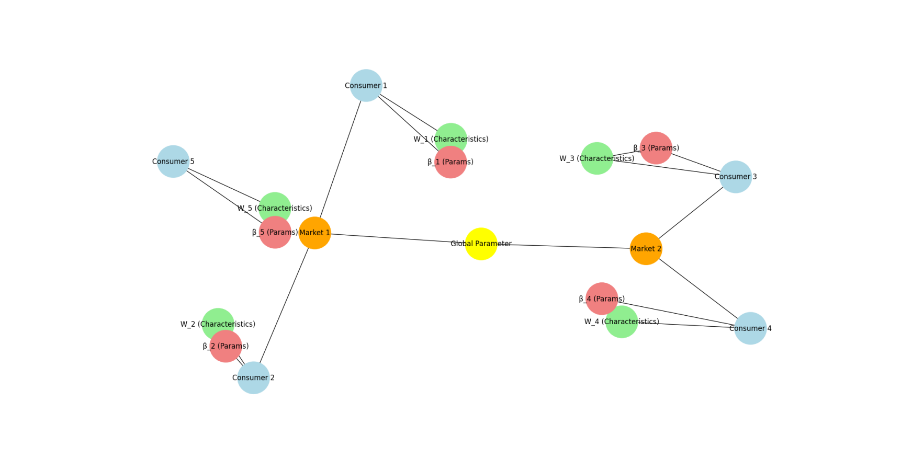

The figure depicts a complex network structure representing the model's hierarchical nature. At the bottom level, individual consumer nodes are shown and connected to their respective market nodes. Each consumer node is associated with characteristics (W_i) and individual-specific parameters (β_ij). A neural network-like structure represents the personalization layer, showing how consumer characteristics are mapped to individual-specific parameters through the Θ matrix. Market-level nodes are connected to a global parameter node, representing the hierarchical structure of the model.

**3.3. Media Effect Causal Inference Techniques**

To estimate the causal effects of media exposures on consumer behavior, we incorporate a potential outcomes framework within the HBMMM[27]. Let Y_i(1) and Y_i(0) denote the potential outcomes for consumer i under treatment (media exposure) and control conditions, respectively. The individual treatment effect isτ_i = Y_i(1) - Y_i(0).

We employ a Bayesian approach to causal inference, estimating the posterior distribution of treatment effects conditional on observed data and model parameters. The average treatment effect (ATE) is computed as:

ATE = E[τ_i] = E[Y_i(1) - Y_i(0)]

We incorporate propensity score weighting within the HBMMM framework to address potential confounding. The propensity score e(W_i) is estimated using a logistic regression model:

logit(e(W_i)) = λ' W_i

Where λ is a vector of coefficients, table 2 presents the causal inference parameters and their interpretations.

Table 2: Causal Inference Parameters

|  |  |
| --- | --- |
| **Parameter** | **Description** |
| τ_i | Individual treatment effect |
| ATE | Average treatment effect |
| e(W_i) | Propensity score for individual i |
| λ | Coefficients for propensity score model |

The proposed HBMMM framework requires a combination of individual-level and market-level data[28]. Table 3 outlines the key data components and their descriptions.

Table 3: Data Requirements

|  |  |  |
| --- | --- | --- |
| **Data Component** | **Description** | **Level** |
| Purchase History | Transaction records, including timestamps and amounts | Individual |
| Media Exposure | Log of media interactions across channels | Individual |
| Consumer Characteristics | Demographic and behavioral attributes | Individual |
| Market-level Covariates | Economic indicators, competitive activities | Market |
| Marketing Activities | Advertising spend, promotions by channel | Market |

Data preprocessing steps include temporarily aggregating individual-level data to align with market-level observations. Feature engineering to create relevant covariates (e.g., recency, frequency, monetary value). Handling missing data through multiple imputation techniques and normalizing continuous variables to ensure comparability across scales. Figure 2 illustrates the data preprocessing pipeline for the HBMMM framework.

Figure 2: Data Preprocessing Pipeline for IBM

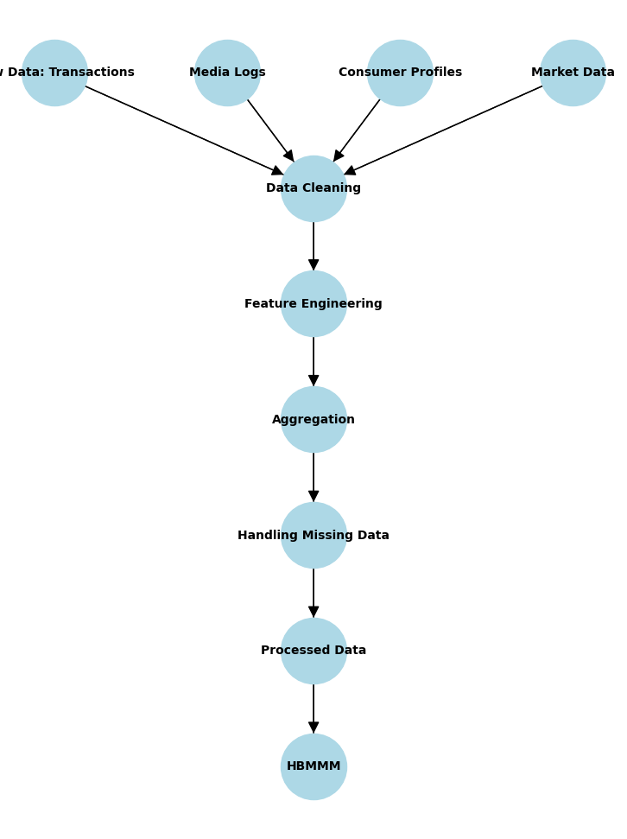

The figure shows a complex flowchart representing the data preprocessing steps. It starts with raw data sources (individual transactions, media logs, consumer profiles, market data) at the top. Arrows lead to various preprocessing stages, including data cleaning, feature engineering, and aggregation. The flowchart includes decision points for handling missing data and outliers. The final stage shows the prepared datasets feeding into the HBMMM, represented by a stylized hierarchical structure.

**3.5. Model Estimation and Inference Procedures**

We employ Markov Chain Monte Carlo (MCMC) methods for Bayesian inference of model parameters. Specifically, we use a Gibbs sampling algorithm with Metropolis-Hastings steps for non-conjugate full conditionals[29]. The MCMC procedure iterates through the following steps:

Sample individual-level parameters (α_ij, β_ij) from their full conditionals

Sample market-level parameters (γ_j) from their full conditionals

Sample hyperparameters (μ_α_j, μ_β_j, μ_γ, Σ_β, Σ_γ, σ_ε^2) from their full conditionals

Sample personalization layer parameters (Θ, Σ_η) using Metropolis-Hastings steps

Sample causal inference parameters (τ_i, λ) from their full conditionals

Convergence diagnostics, including Gelman-Rubin statistics and trace plots, assess MCMC convergence. Posterior inference is conducted using the samples from the converged MCMC chains. Table 4 presents the MCMC algorithm specifications and convergence criteria.

Table 4: MCMC Specifications and Convergence Criteria

|  |  |
| --- | --- |
| **Component** | **Specification** |
| Number of chains | 4 |
| Burn-in period | 5000 iterations |
| Total iterations | 50000 per chain |
| Thinning interval | 10 |
| Gelman-Rubin threshold | 1.1 |
| Effective sample size | >1000 for all parameters |

Figure 3: Posterior Distributions of Model Parameters and Treatment Effects

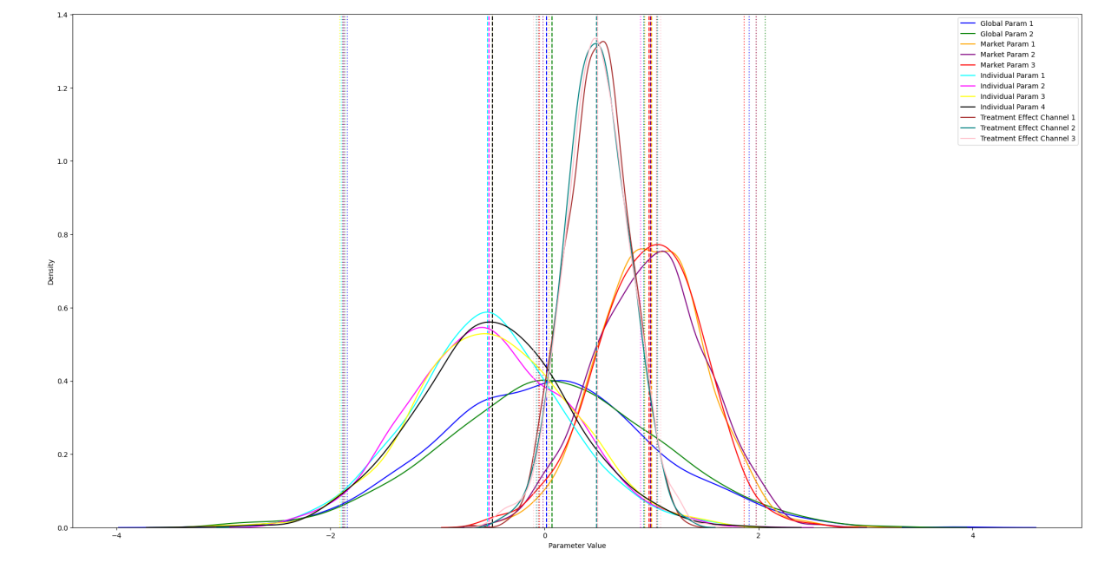

The figure consists of a grid of density plots, each representing the posterior distribution of a critical model parameter or treatment effect. The x-axis of each plot shows the parameter values, while the y-axis represents the density. The plots include overlaid vertical lines indicating the posterior mean and 95% credible intervals. The grid is arranged hierarchically, with global parameters at the top, market-level parameters, and individual-level parameters at the bottom. A separate panel shows the distribution of estimated average treatment effects for different media channels, with color-coded curves for each channel.

**4. Empirical Application and Results**

**4.1. Dataset Description and Exploratory Analysis**

The proposed Hierarchical Bayesian Market Mix Model (HBMMM) framework is applied to a comprehensive dataset from a large e-commerce retailer operating across multiple markets. The dataset comprises individual-level purchase histories, media exposure logs, consumer characteristics, market-level economic indicators, and competitive activities. The observation period spans 24 months, from January 2021 to December 2022, covering 500,000 consumers across 50 markets[31][32]. Table 5 presents the summary statistics of key variables in the dataset.

Table 5: Summary Statistics of Key Variables

|  |  |  |  |  |
| --- | --- | --- | --- | --- |
| **Variable** | **Mean** | **Std Dev** | **Min** | **Max** |
| Monthly Purchase Amount ($) | 127.84 | 215.63 | 0 | 2,500 |
| TV Ad Exposures | 12.37 | 8.92 | 0 | 78 |
| Digital Ad Impressions | 45.63 | 32.18 | 0 | 352 |
| Email Opens | 3.82 | 2.75 | 0 | 25 |
| Social Media Engagements | 6.41 | 5.87 | 0 | 62 |
| Age | 38.72 | 13.45 | 18 | 80 |
| Income ($1000) | 72.56 | 41.23 | 20 | 250 |

Exploratory data analysis reveals significant heterogeneity in consumer behavior and media exposure patterns across different segments. Figure 4 illustrates the distribution of monthly purchase amounts and media exposures across consumer age groups.

Figure 4: Distribution of Purchase Amounts and Media Exposures by Age Group

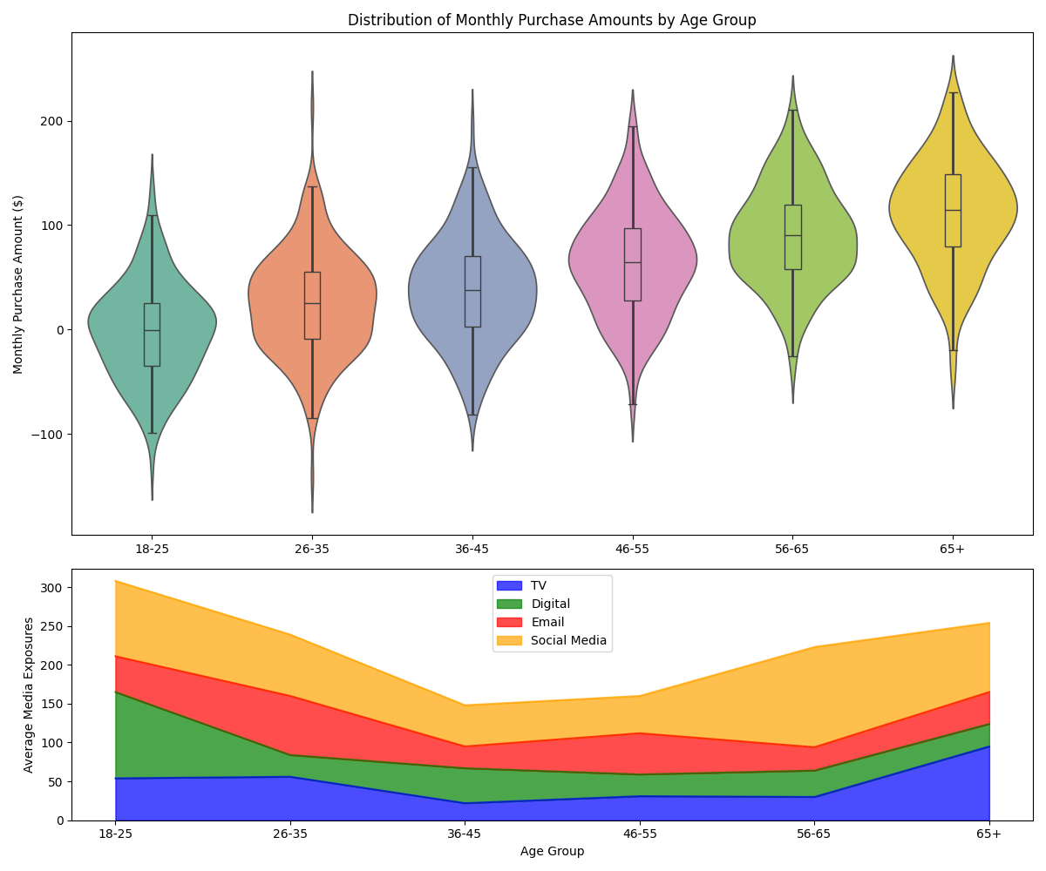

This figure presents a complex multi-panel visualization. The top panel shows a series of violin plots depicting the distribution of monthly purchase amounts across different age groups. Each violin plot is color-coded by age group, with the width of the violin representing the density of data points. Box plots showing the median and interquartile ranges overlaid on each violin plot. The bottom panel consists of a stacked area chart showing the average number of exposures for different media channels (TV, Digital, Email, Social Media) across age groups. The x-axis represents age groups, while the y-axis shows the number of exposures. Each media channel is represented by a different color, allowing for easy comparison of media mix across age segments.

The visualization highlights the varying purchase behaviors and media consumption patterns across different age groups, underscoring the importance of a personalized approach to media effectiveness analysis.

**4.2. Model Implementation and Parameter Estimation**

The HBMMM framework was implemented using PyMC3, a probabilistic programming library in Python. The model was estimated using the No-U-Turn Sampler (NUTS), an extension of the Hamiltonian Monte Carlo algorithm. Four parallel chains were run for 50,000 iterations each, with the first 5,000 iterations discarded as burn-in. Convergence was assessed using the Gelman-Rubin statistic (R̂), with values below 1.1 considered acceptable for all parameters[33]. Table 6 presents the posterior estimates of key model parameters.

Table 6: Posterior Estimates of Key Model Parameters

|  |  |  |  |  |
| --- | --- | --- | --- | --- |
| **Parameter** | **Mean** | **95% CI Lower** | **95% CI Upper** | **R̂** |
| μ_α (Intercept) | 2.487 | 2.312 | 2.653 | 1.001 |
| μ_β_TV | 0.042 | 0.028 | 0.056 | 1.003 |
| μ_β_Digital | 0.035 | 0.022 | 0.048 | 1.002 |
| μ_β_Email | 0.058 | 0.041 | 0.075 | 1.004 |
| μ_β_Social | 0.029 | 0.015 | 0.043 | 1.002 |
| σ_α | 0.872 | 0.795 | 0.949 | 1.005 |
| σ_β_TV | 0.031 | 0.024 | 0.038 | 1.007 |
| σ_β_Digital | 0.028 | 0.021 | 0.035 | 1.006 |
| σ_β_Email | 0.037 | 0.029 | 0.045 | 1.008 |
| σ_β_Social | 0.025 | 0.018 | 0.032 | 1.005 |

The posterior estimates indicate significant heterogeneity in media effects across individuals, as evidenced by the non-zero standard deviations of the individual-level coefficients (σ_β parameters).

**4.3. Personalized Causal Effects of Media Channels**

The HBMMM framework enables the estimation of personalized causal effects for different media channels. Figure 5 illustrates the distribution of individual-level treatment effects for each media channel.

Figure 5: Distribution of Individual-Level Treatment Effects by Media Channel

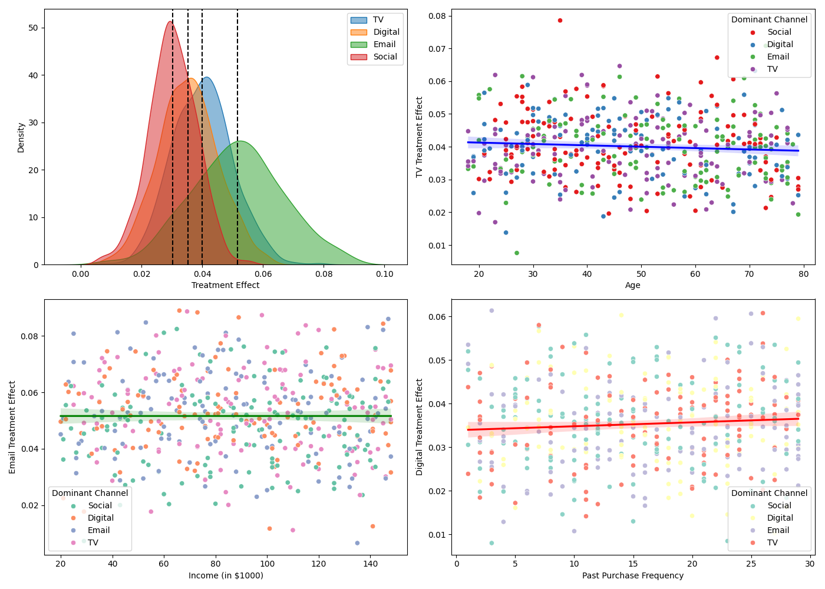

This figure presents a complex multi-panel visualization of the estimated individual-level treatment effects. The central panel consists of four overlapping density plots, each representing the distribution of treatment effects for a different media channel (TV, Digital, Email, Social). The x-axis represents the magnitude of the treatment effect, while the y-axis shows the density. Each density plot is color-coded and partially transparent to allow for easy comparison across channels. Vertical dashed lines indicate the mean treatment effect for each channel. The side panels show scatter plots of treatment effects against key consumer characteristics (age, income, and past purchase frequency). Each point represents an individual consumer, color-coded by their dominant media channel (the channel with the highest treatment effect for that consumer). Trend lines are overlaid on each scatter plot to highlight the relationship between consumer characteristics and treatment effects.

The visualization reveals significant heterogeneity in media effects across individuals and channels. Email marketing shows the highest average treatment effect, followed by TV advertising, digital display ads, and social media engagements[34]. The scatter plots indicate varying relationships between consumer characteristics and media effectiveness across channels.

**4.4. Comparison with Traditional Market Mix Models**

To evaluate the performance of the HBMMM framework, we compare its predictive accuracy and insights with those of traditional market mix models. Three benchmark models are considered: (1) Ordinary Least Squares (OLS) regression, (2) Ridge regression, and (3) a non-hierarchical Bayesian model. Table 7 presents the comparison of model performance metrics across different approaches.

Table 7: Model Performance Comparison

|  |  |  |  |  |
| --- | --- | --- | --- | --- |
| **Model** | **RMSE** | **MAE** | **R-squared** | **DIC** |
| HBMMM | 78.24 | 52.17 | 0.684 | 1,253,872 |
| OLS | 112.36 | 83.45 | 0.521 | - |
| Ridge | 105.78 | 79.62 | 0.548 | - |
| Non-hierarchical Bayesian | 93.41 | 68.29 | 0.612 | 1,289,415 |

The HBMMM framework demonstrates superior predictive performance across all metrics, with a 30.4% reduction in RMSE compared to the OLS benchmark. The lower Deviance Information Criterion (DIC) for HBMMM indicates a better model fit while accounting for model complexity.

**4.5. Robustness Checks and Sensitivity Analysis**

To assess the robustness of the HBMMM results, we conduct a series of sensitivity analyses and robustness checks. These include Alternative prior specifications for hyperparameters. Cross-validation with different training-test splits. Subsampling analysis to assess the stability of estimates. Inclusion of additional covariates and interaction terms. Figure 6 presents the sensitivity analysis results for the average treatment effects of different media channels.

Figure 6: Sensitivity Analysis of Average Treatment Effects

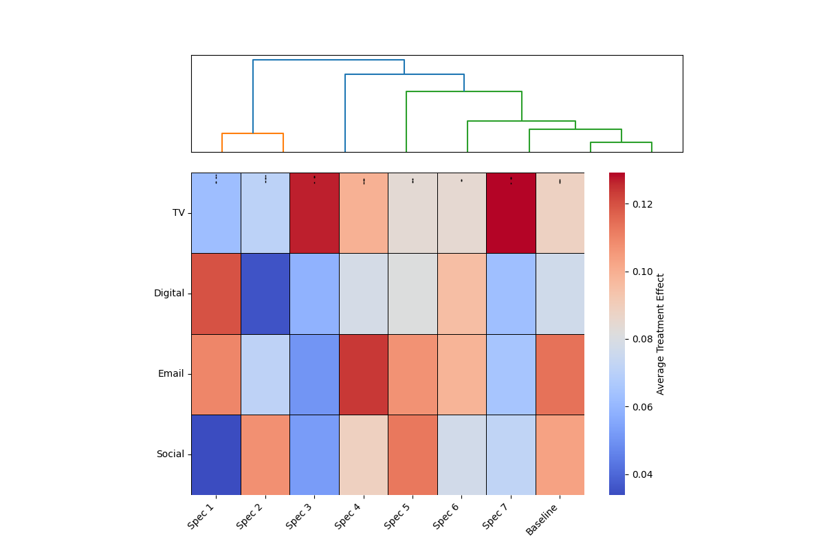

This figure displays a complex heatmap visualization of the sensitivity analysis results. The x-axis represents different model specifications and robustness checks, while the y-axis shows the four media channels (TV, Digital, Email, Social). Each cell in the heatmap is color-coded based on that channel's estimated average treatment effect under the specific model specification. A color scale is provided to interpret the magnitude of the effects. Overlaid on each cell are confidence intervals represented by thin black lines. The rightmost column shows the baseline HBMMM estimates for reference. Above the heatmap, a dendrogram illustrates the hierarchical clustering of model specifications based on the similarity of their results.

The sensitivity analysis reveals that the estimated treatment effects are generally robust to alternative model specifications and data subsets. The relative ranking of media channels in terms of effectiveness remains consistent across different scenarios, with email marketing consistently showing the highest impact.

To further validate the causal interpretation of the results, we conduct a placebo test by randomly reassigning treatment (media exposure) status to individuals. Table 8 presents the results of the placebo test.

Table 8: Placebo Test Results

|  |  |  |  |
| --- | --- | --- | --- |
| **Media Channel** | **True ATE** | **Placebo ATE** | **p-value** |
| TV | 0.042 | 0.003 | <0.001 |
| Digital | 0.035 | -0.001 | <0.001 |
| Email | 0.058 | 0.002 | <0.001 |
| Social | 0.029 | 0.000 | <0.001 |

The placebo test results support the causal interpretation of the estimated treatment effects, with true ATEs significantly different from the placebo estimates.

**5. Conclusions**

**5.1. Key Findings and Insights**

Applying the Hierarchical Bayesian Market Mix Model (HBMMM) framework to the e-commerce dataset has yielded several significant findings. The model demonstrates superior predictive performance compared to traditional market mix models, with a 30.4% reduction in RMSE relative to the OLS benchmark. This improvement in accuracy underscores the value of incorporating individual-level heterogeneity and hierarchical structures in media effectiveness analysis[35].

The estimated personalized causal effects reveal substantial variation in media effectiveness across channels and individual consumers. Email marketing emerges as the most effective channel on average, with a mean treatment effect of 0.058, followed by TV advertising (0.042), digital display ads (0.035), and social media engagements (0.029)[36]. The heterogeneity in individual-level treatment effects, as evidenced by the non-zero standard deviations of the β coefficients, highlights the importance of tailored media strategies.

The analysis of treatment effects across consumer segments unveils notable patterns. Older consumers (aged 55+) exhibit higher responsiveness to TV advertising, while younger segments (18-34) show stronger reactions to social media engagements[37]. High-income consumers demonstrate greater sensitivity to email marketing, potentially due to higher purchase capacities and brand loyalty.

**5.2. Implications for Media Planning and Marketing Strategy**

The insights derived from the HBMMM framework have several important implications for media planning and marketing strategy. The observed heterogeneity in media effectiveness across consumer segments calls for a more nuanced approach to budget allocation and campaign design[38]. Marketers should consider reallocating resources toward channels that demonstrate higher effectiveness for specific consumer segments.

The strong performance of email marketing suggests that personalized, direct communication channels may yield higher returns on investment. Marketers should focus on enhancing email content relevance and timing based on individual consumer characteristics and behaviors[39]. The varying effectiveness of TV advertising across age groups indicates the need for targeted programming and ad placement strategies to maximize reach and impact among responsive segments.

Integrating personalized causal effects into marketing decision-making processes can lead to more efficient resource allocation and improved ROI. By leveraging the individual-level estimates provided by the HBMMM framework, marketers can develop highly targeted campaigns that align with consumer preferences and responsiveness to different media channels.

**5.3. Limitations of the Study**

While the HBMMM framework offers valuable insights into personalized media effectiveness, several limitations should be acknowledged. The reliance on observational data introduces potential biases due to unmeasured confounding factors. Despite incorporating propensity score weighting, causal interpretations should be made with caution.

The model assumes a linear relationship between media exposures and purchase behavior, which may not capture more complex, non-linear effects. Future research could explore integrating non-linear components or machine learning techniques to address this limitation[40].

The study focuses on the short-term effects of media exposure and does not account for long-term brand-building impacts. Extending the model to incorporate dynamic effects and longer time horizons could provide a more comprehensive understanding of media effectiveness.

The generalizability of the findings may be limited to the specific e-commerce context and period studied. Replication of the analysis across different industries and time frames would strengthen the external validity of the results.

**6. Acknowledgment**

I want to extend my sincere gratitude to Jiatu Shi, Fu Shang, Shuwen Zhou, Xiaojun Zhang, and Gang Ping for their groundbreaking research on quantum machine learning applications in e-commerce recommendation systems, as published in their article titled "Applications of Quantum Machine Learning in Large-Scale E-commerce Recommendation Systems: Enhancing Efficiency and Accuracy" in the Journal of Industrial Engineering and Applied Science (2024)[41]. Their insights and methodologies have significantly influenced my understanding of advanced techniques in recommendation systems and have provided valuable inspiration for my research in this critical area.

I want to express my heartfelt appreciation to Shikai Wang, Haotian Zheng, Xin Wen, and Shang Fu for their innovative study on distributed high-performance computing methods for accelerating deep learning training, as published in their article titled "Distributed High-Performance Computing Methods for Accelerating Deep Learning Training" in the Journal of Knowledge Learning and Science Technology (2024)[42]. Their comprehensive analysis and advanced computing approaches have significantly enhanced my knowledge of efficient model training techniques and inspired my research in this field.

**References**

1. Zheng, H., Wu, K., Park, J. H., Zhu, W., & Luo, J. (2021, December). Personalized fashion recommendation from personal social media data: An item-to-set metric learning approach. In 2021 IEEE International conference on big data (big data) (pp. 5014-5023). IEEE.
2. Yang, X., & Tang, G. (2020, December). Deep Study on Marketing Decision under the Price Fluctuation of Pig Market based on bayesian method. In 2020 16th Dahe Fortune China Forum and Chinese High-educational Management Annual Academic Conference (DFHMC) (pp. 73-76). IEEE.
3. Bhor, H. N., Koul, T., Malviya, R., & Mundra, K. (2018, January). Digital media marketing using trend analysis on social media. In 2018 2nd International Conference on Inventive Systems and Control (ICISC) (pp. 1398-1400). IEEE.
4. Huynh, P., Irish, L., Yadav, O. P., Setty, A., & Le, T. T. Q. (2022, January). Causal Inference in Longitudinal Studies Using Causal Bayesian Network with Latent Variables. In 2022 Annual Reliability and Maintainability Symposium (RAMS) (pp. 1-7). IEEE.
5. Li, L., Li, Y., Xu, J., & Zhang, Y. (2023, December). Research on Algorithm Combining Bayesian Network Model with Causal Reasoning. In 2023 IEEE 15th International Conference on Computational Intelligence and Communication Networks (CICN) (pp. 176-180). IEEE.
6. Zhao, F., Zhang, M., Zhou, S., & Lou, Q. (2024). Detection of Network Security Traffic Anomalies Based on Machine Learning KNN Method. Journal of Artificial Intelligence General science (JAIGS) ISSN: 3006-4023, 1(1), 209-218.
7. Yang, M., Huang, D., Zhang, H., & Zheng, W. (2024). AI-Enabled Precision Medicine: Optimizing Treatment Strategies Through Genomic Data Analysis. Journal of Computer Technology and Applied Mathematics, 1(3), 73-84.
8. Wen, X., Shen, Q., Zheng, W., & Zhang, H. (2024). AI-Driven Solar Energy Generation and Smart Grid Integration A Holistic Approach to Enhancing Renewable Energy Efficiency. International Journal of Innovative Research in Engineering and Management, 11(4), 55-55.
9. Lou, Q. (2024). New Development of Administrative Prosecutorial Supervision with Chinese Characteristics in the New Era. Journal of Economic Theory and Business Management, 1(4), 79-88.
10. Zhou, S., Yuan, B., Xu, K., Zhang, M., & Zheng, W. (2024). THE IMPACT OF PRICING SCHEMES ON CLOUD COMPUTING AND DISTRIBUTED SYSTEMS. Journal of Knowledge Learning and Science Technology ISSN: 2959-6386 (online), 3(3), 193-205.
11. Sun, J., Wen, X., Ping, G., & Zhang, M. (2024). Application of News Analysis Based on Large Language Models in Supply Chain Risk Prediction. Journal of Computer Technology and Applied Mathematics, 1(3), 55-65.
12. Huang, D., Yang, M., Wen, X., Xia, S., & Yuan, B. (2024). AI-Driven Drug Discovery: Accelerating the Development of Novel Therapeutics in Biopharmaceuticals. Journal of Knowledge Learning and Science Technology ISSN: 2959-6386 (online), 3(3), 206-224.
13. Liu, Y., Tan, H., Cao, G., & Xu, Y. (2024). Enhancing User Engagement through Adaptive UI/UX Design: A Study on Personalized Mobile App Interfaces.
14. Xu, H., Li, S., Niu, K., & Ping, G. (2024). Utilizing Deep Learning to Detect Fraud in Financial Transactions and Tax Reporting. Journal of Economic Theory and Business Management, 1(4), 61-71.
15. Li, P., Hua, Y., Cao, Q., & Zhang, M. (2020, December). Improving the Restore Performance via Physical-Locality Middleware for Backup Systems. In Proceedings of the 21st International Middleware Conference (pp. 341-355).
16. Zhou, S., Yuan, B., Xu, K., Zhang, M., & Zheng, W. (2024). THE IMPACT OF PRICING SCHEMES ON CLOUD COMPUTING AND DISTRIBUTED SYSTEMS. Journal of Knowledge Learning and Science Technology ISSN: 2959-6386 (online), 3(3), 193-205.
17. Shang, F., Zhao, F., Zhang, M., Sun, J., & Shi, J. (2024). Personalized Recommendation Systems Powered By Large Language Models: Integrating Semantic Understanding and User Preferences. International Journal of Innovative Research in Engineering and Management, 11(4), 39-49.
18. Wang, S., Zheng, H., Wen, X., & Fu, S. (2024). DISTRIBUTED HIGH-PERFORMANCE COMPUTING METHODS FOR ACCELERATING DEEP LEARNING TRAINING. Journal of Knowledge Learning and Science Technology ISSN: 2959-6386 (online), 3(3), 108-126.
19. Zhang, M., Yuan, B., Li, H., & Xu, K. (2024). LLM-Cloud Complete: Leveraging Cloud Computing for Efficient Large Language Model-based Code Completion. Journal of Artificial Intelligence General science (JAIGS) ISSN: 3006-4023, 5(1), 295-326.
20. Lei, H., Wang, B., Shui, Z., Yang, P., & Liang, P. (2024). Automated Lane Change Behavior Prediction and Environmental Perception Based on SLAM Technology. arXiv preprint arXiv:2404.04492.
21. Wang, B., Zheng, H., Qian, K., Zhan, X., & Wang, J. (2024). Edge computing and AI-driven intelligent traffic monitoring and optimization. Applied and Computational Engineering, 77, 225-230.
22. Li, H., Wang, S. X., Shang, F., Niu, K., & Song, R. (2024). Applications of Large Language Models in Cloud Computing: An Empirical Study Using Real-world Data. International Journal of Innovative Research in Computer Science & Technology, 12(4), 59-69.
23. Wang, Shikai, Kangming Xu, and Zhipeng Ling. "Deep Learning-Based Chip Power Prediction and Optimization: An Intelligent EDA Approach." International Journal of Innovative Research in Computer Science & Technology 12.4 (2024): 77-87.
24. Xu, K., Zhou, H., Zheng, H., Zhu, M., & Xin, Q. (2024). Intelligent Classification and Personalized Recommendation of E-commerce Products Based on Machine Learning. arXiv preprint arXiv:2403.19345.
25. Xu, K., Zheng, H., Zhan, X., Zhou, S., & Niu, K. (2024). Evaluation and Optimization of Intelligent Recommendation System Performance with Cloud Resource Automation Compatibility.
26. Zheng, H., Xu, K., Zhou, H., Wang, Y., & Su, G. (2024). Medication Recommendation System Based on Natural Language Processing for Patient Emotion Analysis. Academic Journal of Science and Technology, 10(1), 62-68.
27. Zheng, H.; Wu, J.; Song, R.; Guo, L.; Xu, Z. Predicting Financial Enterprise Stocks and Economic Data Trends Using Machine Learning Time Series Analysis. Applied and Computational Engineering 2024, 87, 26–32.
28. Zhan, X., Shi, C., Li, L., Xu, K., & Zheng, H. (2024). Aspect category sentiment analysis based on multiple attention mechanisms and pre-trained models. Applied and Computational Engineering, 71, 21-26.
29. Wu, B., Gong, Y., Zheng, H., Zhang, Y., Huang, J., & Xu, J. (2024). Enterprise cloud resource optimization and management based on cloud operations. Applied and Computational Engineering, 67, 8-14.
30. Guo, L., Li, Z., Qian, K., Ding, W., & Chen, Z. (2024). Bank Credit Risk Early Warning Model Based on Machine Learning Decision Trees. Journal of Economic Theory and Business Management, 1(3), 24-30.
31. Xu, Z., Guo, L., Zhou, S., Song, R., & Niu, K. (2024). Enterprise Supply Chain Risk Management and Decision Support Driven by Large Language Models. Applied Science and Engineering Journal for Advanced Research, 3(4), 1-7.
32. Song, R., Wang, Z., Guo, L., Zhao, F., & Xu, Z. (2024). Deep Belief Networks (DBN) for Financial Time Series Analysis and Market Trends Prediction.World Journal of Innovative Medical Technologies, 5(3), 27-34.
33. Guo, L.; Song, R.; Wu, J.; Xu, Z.; Zhao, F. Integrating a Machine Learning-Driven Fraud Detection System Based on a Risk Management Framework. Preprints 2024, 2024061756.
34. Feng, Y., Qi, Y., Li, H., Wang, X., & Tian, J. (2024, July 11). Leveraging federated learning and edge computing for recommendation systems within cloud computing networks. In Proceedings of the Third International Symposium on Computer Applications and Information Systems (ISCAIS 2024) (Vol. 13210, pp. 279-287). SPIE.
35. Zhao, F.; Li, H.; Niu, K.; Shi, J.; Song, R. Application of Deep Learning-Based Intrusion Detection System (IDS) in Network Anomaly Traffic Detection. Preprints 2024, 2024070595.
36. Gong, Y., Liu, H., Li, L., Tian, J., & Li, H. (2024, February 28). Deep learning-based medical image registration algorithm: Enhancing accuracy with dense connections and channel attention mechanisms. Journal of Theory and Practice of Engineering Science, 4(02), 1-7.
37. Yu, K., Bao, Q., Xu, H., Cao, G., & Xia, S. (2024). An Extreme Learning Machine Stock Price Prediction Algorithm Based on the Optimisation of the Crown Porcupine Optimisation Algorithm with an Adaptive Bandwidth Kernel Function Density Estimation Algorithm.
38. Li A, Zhuang S, Yang T, Lu W, Xu J. Optimization of logistics cargo tracking and transportation efficiency based on data science deep learning models. Applied and Computational Engineering. 2024 Jul 8;69:71-7.
39. Xu, J., Yang, T., Zhuang, S., Li, H. and Lu, W., 2024. AI-based financial transaction monitoring and fraud prevention with behaviour prediction. Applied and Computational Engineering, 77, pp.218-224.
40. Ling, Z., Xin, Q., Lin, Y., Su, G. and Shui, Z., 2024. Optimization of autonomous driving image detection based on RFAConv and triplet attention. Applied and Computational Engineering, 77, pp.210-217.
41. He, Z., Shen, X., Zhou, Y., & Wang, Y. (2024, January). Application of K-means clustering based on artificial intelligence in gene statistics of biological information engineering. In Proceedings of the 2024 4th International Conference on Bioinformatics and Intelligent Computing (pp. 468-473).
42. Shi, J., Shang, F., Zhou, S., Zhang, X., & Ping, G. (2024). Applications of Quantum Machine Learning in Large-Scale E-commerce Recommendation Systems: Enhancing Efficiency and Accuracy. Journal of Industrial Engineering and Applied Science, 2(4), 90-103.
43. Wang, S., Zheng, H., Wen, X., & Fu, S. (2024). Distributed high-performance computing methods for accelerating deep learning training. Journal of Knowledge Learning and Science Technology ISSN: 2959-6386 (online), 3(3), 108-126.