**Strengthening the Community Economy through Empowerment Mother House Ladder in Village Lako Akelamo Regency**

**Prince Charles Heston Runtunuwu1, Amran Husen2**

1,2) Khairun University, Indonesia

Correspondence email: p rincecharles.unkhair@gmail.com

|  |
| --- |
|  |

|  |  |  |
| --- | --- | --- |
| **Article history** |  | Submitted: 2024/04/16; Revised: 2024/05/12; Accepted: 2024/06/21 |
| **Abstract** |  | Fish is the biggest asset in Lako Akelamo Village, West Halmahera Regency. This program aims to improve the community's economy by Strengthening Community Economy through Empowering Housewives in Lako Village, Akelamo Regency. This service uses the PAR (Participatory Action Research) method by providing direct education to the community, including lectures, question-and-answer methods, and FGD. The results of the Community Service Program in the form of fish processing training need to be evaluated so that this training can become a provision of life skills for the local community. This form of life skills can improve skills to become innovations with economic and productive value. It can be concluded that through the program of processing fish into varied and productive food, skills can be improved to become an economic and productive innovation for the community and the village. |
| **Keywords** |  | Fish Processing; Fish Tell; Food; Productive; Varied. |
| Creative Commons License |  | **© 2024 by the authors**. This is an open-access publication under the terms and conditions of the Creative Commons Attribution 4.0 International (CC BY SA) license, <https://creativecommons.org/licenses/by-sa/4.0/>. |

**INTRODUCTION**

Lapasi Village is located in Sahu District, Regency West Halmahera, North Maluku Province, with an area of ± 7,000 hectares based on data from the village report in 2019. The village has 593 residents and 188 families (card family). Lako Akelamo Village has three assets and daily livelihoods, including Rattan, Rubber, and Fish [1]. However, most village residents prefer to work as personal fishermen because fish is the biggest asset in the village; this is based on results observation And interviews obtained directly from service Fishery units 1 Regency West Halmahera. In the past two years, namely 2019-2020, West Halmahera Regency received the award for the largest fish income in Kalimantan Central, and one of the largest fish contributors is Lako Akelamo Village [2]. Law Number 45 of 2009 concerning amendments to Law Number 31 the Year 2004 About fishery, chapter 1 explained that Fish are all types of organisms Which all over or part of cycle life is at in environment waters. Fish is not only obtained through fishing in the river, as is the case in Lako Akelamo Village Subdistrict Sahu, Regency West Halmahera. The matter here is That makes average residents in Lako Akelamo Village prefer to work as fishermen because of the abundant source of Power; natural form Fish are found in Lako Akelamo Village [3].

The observations found that the fish caught in Lako Akelamo Village 100% is only sold by village residents directly to agents who come to the village or sell it directly to the market [4]. Society never tries to process the results of fish that become a type of food, Which is other than Pempek. The role Mother House ladder or woman in Lako Akelamo Village in creating processed fish production is very important [5].

Pempek is food Which Lots contains proteins, especially animal proteins sourced from fish. Pempek is a traditional food typical of Palembang, Sumatra, South, Which almost everyone increasingly likes its existence and can be found everywhere, both on a small scale and a large scale, both in simple and luxurious places, from the artisans' baskets arrived at the hotel [6]. Pempek is made from ingredients such as ground fish meat, flour tapioca, water, salt, and spices as adder wish flavor [7]. Pempek consists of several forms such as egg pempek, lenjer pempek, submarine pempek, pempek pastel, pempek know, pempek curly, pempek loose, And pempek there's something. Besides pempek, processed fish Can Also be made to become a type food Kerbas (shrimp crisp wet). Kerupuk / wet is a typical food made from river fish from Putussibau, Ibu City Regency Kapuas Upstream, Kalimantan West [8]. Although his name is Crackers, at a glance, the wet crackers look like typical Palembang Pempek. Shrimp is a crisp, wet, elongated oval shape with a length of 15 to 30 cm with a diameter of 2 to 5 cm (Inong Apprenticeship, 2015). Variant from shrimp crisp wet Alone Enough diverse There is Which fatty, There is Which No, and made from base various type fish [9]. Matter This causes the price of processing fish into varied and productive food to increase several times compared to directly selling fish. Will but attention government local in development Skills in complaint fish This Can say Not yet Once done in Village because there is no fish-based food from Lako Akelamo Village This. The number of fish in Lako Akelamo Village is large and can be processed into various forms of varied and productive food [10]. Therefore, based on an analysis of Lako Akelamo Village, the village residents need to be given fish processing training so that the residents of Lako Akelamo Village process fish into varied and varied food productive as well as improve the economy of villagers Lako Akelamo [11].

This program aims to improve the community's economy by Strengthening Community Economy through Empowering Housewives in Lako Village, Akelamo Regency. This form of life skills can improve skills to become innovations with economic and productive value. It can be concluded that through the program of processing fish into varied and productive food, skills can be improved to become an economic and productive innovation for the community and the village.

**METHOD**

This service uses the PAR (Participatory Action Research) method by providing direct education to the community, including lectures, question-and-answer methods, and FGD [12]. The method used in empowering homemakers in Lako Akelamo Village is training in processing fish into varied and productive food participants who follow as many as eight-person Mother House ladder, Which is the inhabitant's Village Lako Akelamo. Activity training consists of several stages: presentation material, guided exercises, demonstrations, and assistance. Presenting material uses an enriched adult learning approach with learning methods including lecture, discussion, and question and answer. Learning methods that are applied with a learning approach, as mentioned above, are expected to improve the motivation for participants to process fish directly variation and be productive. To support process learning, done activity exercise guided about choosing fish that can be processed to make food so that the fish you choose can utilized as a whole. And also provides plans for processing fish into modern food types, Which vary like Fish crackers And Kerbas (Shrimp crisp Wet). It also explains the marketing and price of fish, Which are Already in exercise so that the public can increase the economy through the sale of fish, Which varies demonstration and mentoring methods, by directly practicing choosing, cleaning, and processing it. Then, practice using tools that have already been bought, making things easier for the community in fish processing.

**FINDINGS AND DISCUSSION**

Implementation training consists of several stages. The first activity to prepare for the training was determining the location and date of activity implementation training. Activity training was held in Village Lako Akelamo, Sahu sub-district, West Halmahera district, at the Village Hall on 17th August 2021 from 09.00 to 16.00 WIB. The next stage is making a poster to distribute to all people in the village, especially mothers, to get it participate in training activities. After obtaining permission, the KUBERMAS team participants began to plan the activities and materials that would be delivered, as well as all preparations that support the training process. Figure 1 shows activity posters posted on the site program.

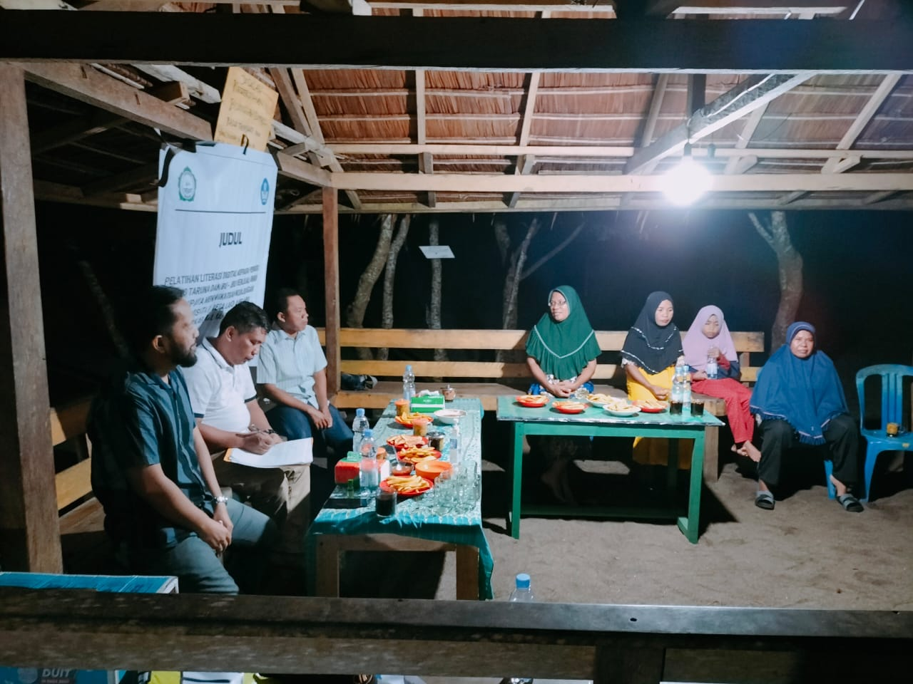

Picture 1. Lecture Material activity

The practice of training in processing fish into modern food was carried out on 17th August 202 3, from 1 9.00 to 2 1.00 WI T fish processing training becomes Modern food was attended by eight people consisting of 4 people from RT 1 and 4 people from RT 2 which is shown in Figure 2. The participants brought cooking utensils from the House. Some types of food can be processed from Mantahukan fish into modern types, Pempek-Pemek and Kerbas (Shrimp crisp Wet), along with tools, materials, and methods of making. Among them is Recipe Make Fish crackers. Picture 3 shows the tools and materials used in this training.

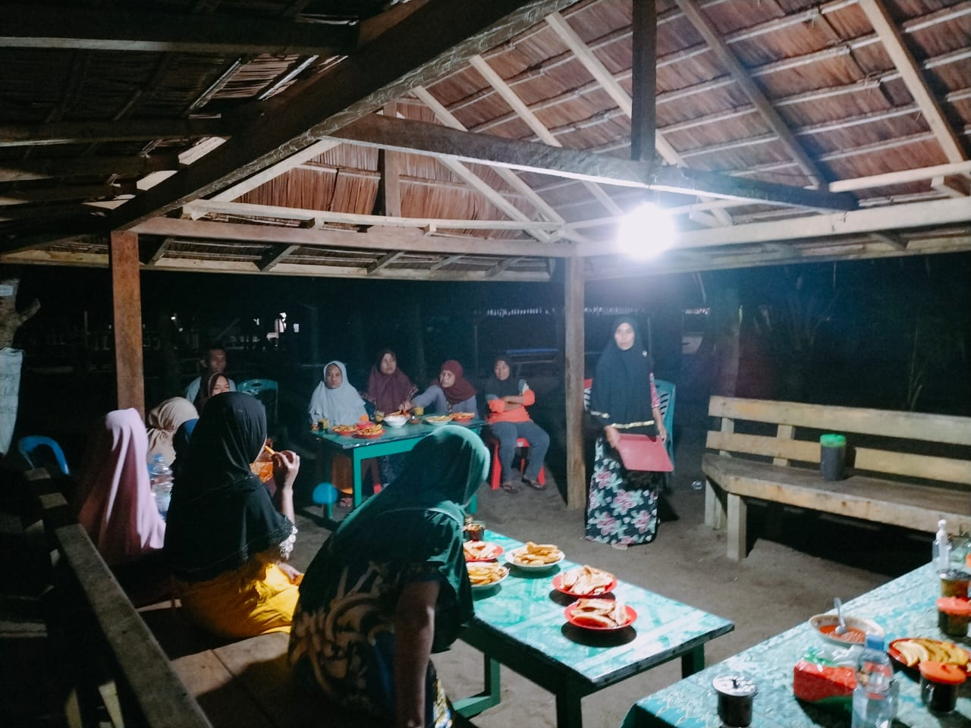

Picture 2. Participant activity training

Processing fish into varied and productive food in Lako Akelamo Village, District Sahu, West Halmahera Regency. This has been done through training activities. Training is held in Lako Akelamo Village; this is one of the student service programs KUBERMAS in society. This community service can help provide solutions to the community to develop insight, increase knowledge, help improve the economy, and maintain the health public [13]. One of the community service programs KUBERMAS students are implementing is training in processing Mantahukang fish into modern foods such as Pempek and Kerbas (Wet Crackers) [14]. The implementation of this training is based on training for adults. This training is intended for mothers in general who live in Lako Akelamo Village, which consists of 2 RT (Rukun Tetangga) and 1 RW (Rukun Warga) [15]. So, taking part in this training is a messenger from Village Lako Akelamo as much 8 People consisting of 4 people from RT 1 And 4 people from RT 2.

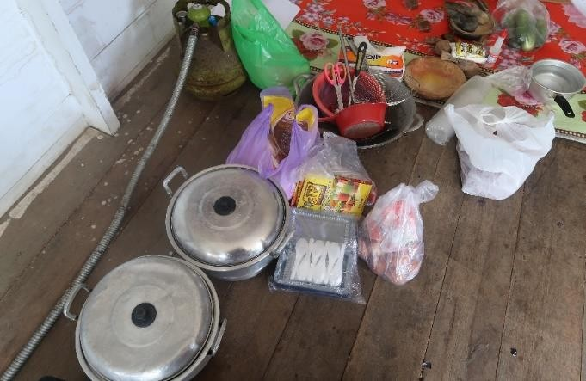

Picture 3. Tool and material activity

Food packaging training is also taught in fish processing training varied and innovative food in Lako Akelamo Village. Figure 4 shows the processed results of food made in training. Choosing practical and economical packaging becomes a consideration in packaging processed foods. Apart from that, giving the product name is also important. So, that training Also loads How to make *brands* or brand Name products [16].

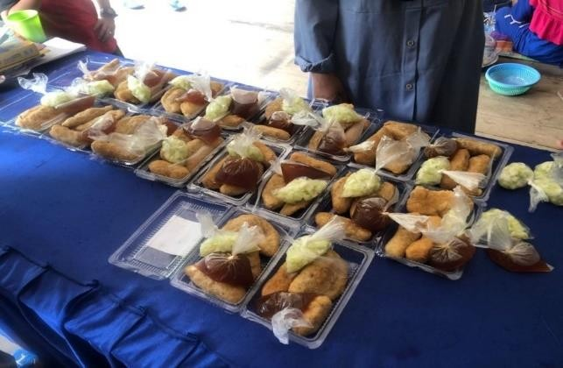

Picture 4. Results processed

Practical training on processing fish into modern food was carried out on 17th August, 202 3, from 09.00 to 16.00. WIB fish processing training becomes Modern food was attended by eight people consisting of 4 from RT 1 and 4 from RT 2.

According to the training objectives explained above, the benefit of the training is devotion. This society is as follows: By the training carried out in Lako Akelamo Village, it is hoped that they will have an influence, which is very important for the public in increasing Skills in life and improving the economy [17]. The population's education level will increase as the economy improves, especially the generation successor. If the public has the Skills to process fish in a way that varies will add knowledge and nutrition so that the public will more easily use the fish for his pet [18]. Apart from that, people can also get to know the types of food made from processed fish. With described content nutrition, benefits, and techniques, marketing will give knowledge so that the public can guard their health, consume fish with various variations, and be motivated to produce processes to sell it [19].

It is hoped that the Community Service Program, in the form of training, can provide deep solutions to improve life skills for the community, especially homemakers, steps to increase quality human resources, even those in society it doesn't get an education but can be trained by giving training in fish processing [20]. Having this community service program means it exists concern college tall to problem Which faced society in solving educational, economic and life skills problems [21]. Apart from that, it is connected ties between higher education institutions and the community so that the community feels like they are part of efforts to help the population's economy and educate the nation's children. This community service activity will help the Department's government program, Fishery in the Regency Lamongan, encourage eating fish [22].

This Community Service program in the form of fish processing training is necessary evaluation so that this training can become a life skill for the local community [23]. These Life Skills form increased skills so that they can become a spell innovative, economical, and productive [24]. The evaluation criteria are in the form of follow-up from the community, namely that the community can process itself into other varied foods besides the processing that has been taught and promote results of processed fish to market [25]. As for criteria simple and reject measuring in the Community Service program are: Public capable process fish by that taught moment training; Public capable process fish become variation other; Public capable process fish become food Healthy; Processing fish This Can become life skills for society; Processing fish this can become a home industry for the public; Expected public can become productive in increase economy to the front; Public capable promote results processed fish to parties related, like supermarket, schools and markets; Public can intertwine work the same with service fishery in frame help program government.

**CONCLUSION**

Fish Tell me as Wrong One fish water bid Which product processed Which diverse. Product process: There is utilization from meat, bone, or thorns, And skin fish. These processed products include Fish Crackers and Kerbas (Wet Crackers). Process This diversification of fish processing requires technology to increase output. Will but technology Which There is No everything is technology Which advanced. Technology, even simple ones, can be implemented. Based on this, the village community and we can utilize the opportunity in the system processing fish. Temporary That necessary exists institution support to assist Village communities in diversifying their processing. With the public expectations, Village Lako Akelamo is especially capable of increasing well-being and economy Village, the more proceed.

**REFERENCES**

[1] A. E. Ayorbaba, N. Widiastuti, A. S. Ananta, and P. Boli, “Biological Aspects of Squids (loligo sp.) Caught by Fishermen in Manokwari Waters,” *J. Sumberd. Akuatik Indopasifik*, vol. 3, no. 1, p. 65, 2019, doi: 10.46252/jsai-fpik-unipa.2019.vol.3.no.1.67.

[2] T. Muliati, N. A., and W. O. Piliana, “Social Economic Condition Of Fishermen Community In Tanjung Tiram Village, North Moramo District, South Konawe Regency,” *J. Sos. Ekon. FPIK UHO*, vol. 3, no. 3, pp. 216–228, 2018.

[3] F. Yunda Sari, Y. Sapta Pranoto, R. Purwasih, J. Agribisnis, and F. Pertanian Perikanan dan Biologi, “Analysis of Salted Fish (Case Study of Rebo Village, Sungailiat District, Bangka District) Analisis Usaha Ikan Asin (Studi Kasus Desa Rebo Kecamatan Sungailiat Kabupaten Bangka),” *J. Integr. Agribus.*, vol. 2, no. 1, pp. 20–36, 2020, doi: 10.33019/jia.v2i1.xxxx.

[4] M. F. Flores, “Understanding the challenges of remote working and it’s impact to workers,” *Int. J. Bus. Mark. Manag.*, vol. 4, no. 11, pp. 40–44, 2019.

[5] A. S. Sebsibe, A. S. Argaw, T. B. Bedada, and A. A. Mohammed, “Swaying pedagogy: A new paradigm for mathematics teachers education in Ethiopia,” *Soc. Sci. Humanit. Open*, vol. 8, no. 1, pp. 1–10, 2023, doi: 10.1016/j.ssaho.2023.100630.

[6] S. Mukherjee, "Challenges to Indian micro, small scale and medium enterprises in the era of globalization," *J. Glob. Entrep. Res.*, vol. 8, pp. 1–19, 2018.

[7] B. Blagojevic *et al.*, “Drivers, opportunities, and challenges of the European risk-based meat safety assurance system,” *Food Control*, vol. 124, p. 107870, 2021.

[8] E. Lukitaningsih, A. Rohman, M. Rafi, A. F. Nurrulhidayah, and A. Windarsih, “In vivo antioxidant activities of Curcuma longa and Curcuma xanthorrhiza: A review,” *Food Res.*, vol. 4, no. 1, pp. 13–19, 2020, doi: 10.26656/fr.2017.4(1).172.

[9] U. Soleha and M. B. Qomaruddin, “Saltwater fish consumption pattern and incidence of hypertension in adults: A study on the population of Gresik coast, Indonesia,” *J. Public health Res.*, vol. 9, no. 2, p. jphr-2020, 2020.

[10] N. Miliyanti, R. Rinaldy, and R. Alghifari, “Application of Participatory Rural Appraisal (PRA) Techniques in Waste Problems in Sukamanis Village Kadudampit District,” *J. Pengabdi. Masy. Bestari*, vol. 1, no. 9, 2022, doi: 10.55927/jpmb.v1i9.2111.

[11] J. Rajadurai, N. M. Sapuan, S. Daud, and N. Abidin, “The marketability of technical graduates from higher educational institutions (HEIs) offering technical and vocational education and training (TVET): a case from Malaysia,” *Asia-Pacific Educ. Res.*, vol. 27, pp. 137–144, 2018.

[12] V. Salviana, I. R. Fuadiputra, M. R. Bustami, and G. K. Jha, “Participatory Action Research ( PAR ) Model for Developing A Tourism Village in Indonesia,” *J. Local Gov. Issues ( LOGOS )*, vol. 5, no. 2, pp. 193–207, 2022.

[13] Bawuro AA, “Bioaccumulation of heavy metals in some tissues of fish in lake geriyo, adamawa, nigeria,” Journal of environmental and public health.

[14] I. Y. Marcelina, K. Bintoro, and L. C. Nawangsari, “Analisis Marketing Mix pada Keputusan Pembelian di Aneka Frozen Foods,” *Innov. J. Soc. Sci. Res.*, vol. 3, no. 3, pp. 5301–5312, 2023.

[15] Y. Hasanah, “Eco enzyme and its benefits for organic rice production and disinfectant,” *J. Saintech Transf.*, vol. 3, no. 2, pp. 119–128, 2021, doi: 10.32734/jst.v3i2.4519.

[16] L. Boonk, H. J. M. Gijselaers, H. Ritzen, and S. Brand-Gruwel, “A review of the relationship between parental involvement indicators and academic achievement,” *Educ. Res. Rev.*, vol. 24, pp. 10–30, 2018.

[17] C. Chauhan, V. Parida, and A. Dhir, “Linking circular economy and digitalisation technologies: A systematic literature review of past achievements and future promises,” *Technol. Forecast. Soc. Change*, vol. 177, p. 121508, 2022.

[18] V. Sethi *et al.*, “Incidence of Side-effects After Weekly Iron and Folic Acid Consumption Among School-going Indian Adolescents,” *Indian Pediatr.*, vol. 56, pp. 33–34, 2019.

[19] M. Hemalatha and P. Visantini, “Potential use of eco-enzyme for the treatment of metal based effluent,” *IOP Conf. Ser. Mater. Sci. Eng.*, vol. 716, no. 1, 2020, doi: 10.1088/1757-899X/716/1/012016.

[20] A. P. Nugraha, C. Wibisono, B. Satriawan, Indrayani, Mulyadi, and Damsar, “The Influence Of Transformational Leadership, Job Crafting, Job Satisfaction, And Self-Efficacy On Job Performance Through Work Engagement Of State Civil Apparatus As An Intervening Variable In The Digital Era Of Cases In The Local Government Of Karimun R,” *Cent. Eur. Manag. J.*, vol. 30, no. 3, pp. 2336–2693, 2022.

[21] A. Kohne, *Business development: Customer-oriented business development for successful companies*. Springer Fachmedien Wiesbaden, 2019. doi: 10.1007/978-3-658-24726-3.

[22] R. Chaves-Avila and J. R. Gallego-Bono, “Transformative policies for the social and solidarity economy: The new generation of public policies fostering the social economy in order to achieve sustainable development goals. The European and Spanish cases,” *Sustainability*, vol. 12, no. 10, p. 4059, 2020.

[23] A. Kasapa and C. Gyan, “Community Participation in Planning Social Infrastructure Delivery in Ghana’s Local Government: A Case Study of Shai Osudoku District,” *J. Dev. Policy Pract.*, p. 24551333231165830, 2023.

[24] M. Saha, “English teachers’ attitudes towards learners: Effects on the rural pedagogies in Bangladesh,” *Ampersand*, vol. 10, pp. 1–9, 2023, doi: 10.1016/j.amper.2022.100107.

[25] Y. Jamiah, F. Fatmawati, and E. Purwaningsih, “Internalization of Students’ Nationalism Sense through Outbound Learning Based on Local Wisdom,” *JETL (Journal Educ. Teach. Learn.*, vol. 4, no. 2, pp. 339–344, Sep. 2019, doi: 10.26737/jetl.v4i2.1642.